Larkin Wisdom

Part 1: Theory

Question 1: I could not figure out this question

Question 2:

There are four sub-intervals.

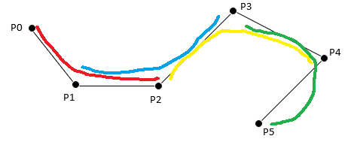

Red = 1st, Blue = 2nd, Yellow = 3rd, Green = 4th

Question 3:

1. The knot values go from 0 to 11.
2. 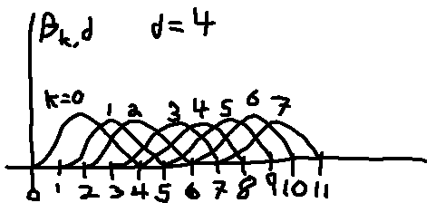
3. 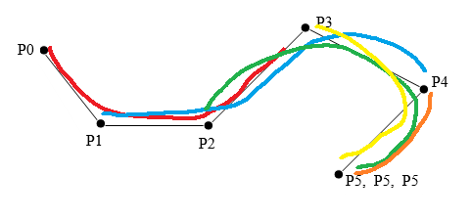

Red = 1, Blue = 2, Green = 3, Yellow = 4, Orange = 5